CS 5402 – Intro to Data Mining
Fall 2019
HW #6
Submit as a single pdf file via Canvas by 11:59 p.m. on Nov. 6, 2020

- Write a Python program to create a Support Vector Machine for the dataset shown below. Note that a linear kernel is likely not the best to use since the data points are not linearly separable. You must determine what is the best kernel to specify when you call the Python sklearn SVC function; JUSTIFY YOUR SELECTION! Include a listing of your Python source code AND show what your SVM predicts for each of the following points: (4, 5), (2, 2), (1, 1), (0, -0.5). (5 pts.)
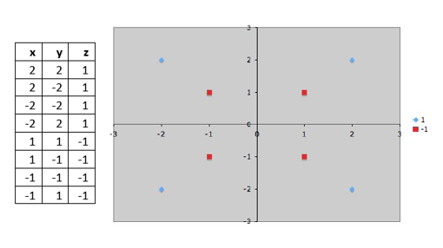

import numpy as np
import pandas as pd
import matplotlib.pyplot as plt
from sklearn.svm import SVC

df = pd.read_csv('HW6-1_Data.csv')

# Just for graphing purposes, change non-decision attr's
# to have numeric values
df= df.replace({'z': r'positive'}, {'z':1}, regex=True)
df=df.replace({'z': r'negative'}, {'z':-1}, regex=True)
X = df.iloc[:, 0:2].values
y = df.iloc[:, 2].values
r,_ = df.shape

# Display original data points
plt.scatter(X[:, 0], X[:, 1], c=y, s=r, cmap='winter')
plt.show()

'''
Link to the source of scikit-learn page
https://scikit-learn.org/stable/modules/generated/sklearn.svm.SVC.html
'''

# Make a linear SVM
#model = SVC(kernel='linear')

# Make a Polynomial SVC
'''This seems to work the best'''
model = SVC(kernel = 'poly', degree = 2)

# Make a sigmoid SVC
#model = SVC(kernel = 'sigmoid', degree = 10)

# Make a precomputed SVC
#model = SVC(kernel = 'precomputed', degree = 2)

model.fit(X, y)
print(model.support_vectors_) # The support vectors
#print(model.coef_) # The weights (x and y)
print(model.intercept_) # Theintercept

# Function to plot SVM boundary lines-cool!
def plot_svc_decision_function(model, ax=None, plot_support=True):
if ax is None:
ax = plt.gca()

xlim = ax.get_xlim()
ylim = ax.get_ylim()

# Create grid to evaluate model
x = np.linspace(xlim[0], xlim[1], 30)
y = np.linspace(ylim[0], ylim[1], 30)
Y, X = np.meshgrid(y, x)
xy = np.vstack([X.ravel(), Y.ravel()]).T
P = model.decision_function(xy).reshape(X.shape)

# Plot decision boundary and margins
ax.contour(X, Y, P, colors='k',
levels=[-1, 0, 1], alpha=0.5,
linestyles=['--', '-', '--'])

# Plot support vectors
if plot_support:
ax.scatter(model.support_vectors_[:, 0],
model.support_vectors_[:, 1],
s=300, linewidth=1, facecolors='none')
ax.set_xlim(xlim)
ax.set_ylim(ylim)

# Call the function to show points and SV boundaries
plt.scatter(X[:, 0], X[:, 1], c=y, s=50, cmap='winter')
plot_svc_decision_function(model)
plt.show()

# Make predictions (will be array([-1]) or array([1]))

print("Test prediction for [2,2] is: ",model.predict([[2,2]]))
print("Test prediction for [-2,2] is: ",model.predict([[-2,2]]))
print("Test prediction for [-1,-1] is: ",model.predict([[-1,-1]]))

# Make predictions (will be array([-1]) or array([1]))
print("SVM prediction for [4,5] is: ",model.predict([[4,5]]))
print("SVM prediction for [2,2] is: ",model.predict([[2,2]]))
print("SVM prediction for [1,1] is: ",model.predict([[1,1]]))
print("SVM prediction for [0,-0.5] is: ",model.predict([[0,-0.5]]))

Polynormal in the SVM kernal
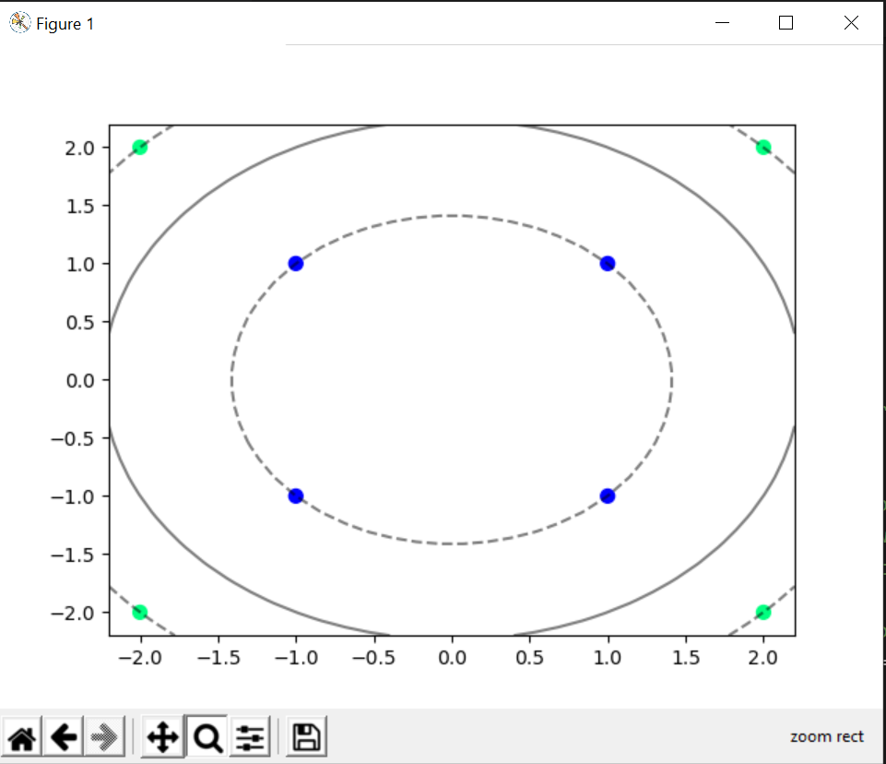

- Write a Python function which, given a dataframe, constructs (and returns) a Naïve Bayesian network.
You can assume that all of the attributes have nominal values and that the decision attribute is the last attribute in the dataframe.
Apply Laplace smoothing to the conditional probabilities of the attributes (as explained in class) using a value of λ = 1.
Output the conditional probability table for each node in the Bayesian network so that we can check your work!
Test your function by running it on contact-lenses.csv AND hypothyroid.csv (both of which are posted on Canvas in Files -> Files for Weka Examples). Note that you can check your work by running Classify -> weka -> Classifiers -> bayes -> NaiveBayesSimple in Weka.
ALSO demonstrate that you have successfully created the Bayesian network by executing code that predicts an instance of your choice for each test file. Clearly specify exactly what you are making a prediction for and what the result is. (40 pts.)
Note: You will NOT get full credit for your solution if you hard-code your code to work just for the specified test datasets!

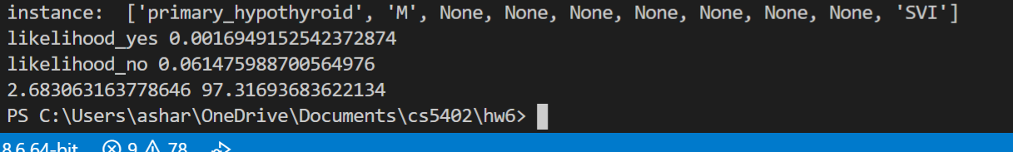
import numpy as np, pandas as pd
from sklearn import preprocessing
import yaml
from pomegranate import *

#df = pd.read_csv('contact-lenses.csv')
df = pd.read_csv('hypothyroid.csv')

# Making the Column index
col_list = []
for i in df:
col_list.append(i)

#print(col_list)

# Lambda is always equal to 1
_lambda = 1

def myMap(df, col_list):
atr = {}
for i in df[col_list]:
atr[i] = i
return list(atr)

# Laplace Smoothing
# P(x1 = aj | y = Ck) = (sum(I*(x1 = aj, y = Ck) + Lambda)/()
#
def ConditionalProbabilityT(x1, A1, y1, A2, k):
Top = df.loc[(df[x1] == A1) & (df[y1] == A2),:].index.size
Bot = df.loc[(df[x1] == A1),:].index.size

return (Top + _lambda)/(Bot+ k * _lambda)

def Bayesian_Network(dataframe, title):
num_size = dataframe.index.size
P = []
model = BayesianNetwork(title)

decision_str = col_list[len(col_list) - 1]

#print("decision", decision_str)
dictionary = {}
#k = len(myMap(dataframe, decision_str))
for i in myMap(dataframe, decision_str):
k = len(myMap(dataframe, decision_str))
dictionary[i] = ((dataframe.loc[dataframe[decision_str] == i,:].index.size)+(_lambda))/(num_size+k*_lambda)

# Table for discrete Distrubtion(isn't conditional on any other nodes)
P.append(DiscreteDistribution(dictionary))
#print(P)
for i in range(0,len(col_list)-1):
con = []
L = len(myMap(dataframe, col_list[i]))
for j in myMap(dataframe, decision_str):
for k in myMap(dataframe, col_list[i]):
con.append([j,k,
ConditionalProbabilityT(decision_str, k, col_list[i], k, L)])

C = ConditionalProbabilityTable(con, [P[0]])

P.append(C)
#print(P)

# Create nodes with their probability tables
s1 = Node(P[0], name=decision_str)

#model.add_states(s1, s2, s3, s4, s5) # add the nodes
model.add_state(s1)

# add the nodes and edges
for i in range(1, len(P)):
s2 = Node(P[i], name = col_list[i-1])
model.add_state(s2)
model.add_edge(s1,s2)

model.bake()
return model

in_model = Bayesian_Network(df,"Bayesian Network")
#print(in_model)
# Hardcode Prediction
# sex,on_thyroxine,on_antithyroid_medication,thyroid_surgery,lithium,goitre,hypopituitary,psych,referral_source,Class
'''testing'''
#instance = ['negative','M','f','f','f','f','f','f','t','SVHC']
instance = ['primary_hypothyroid',"M",None,None,None,None,None,None,None,'SVI']

# From Leopold's notes below
likelihood_yes = in_model.probability([instance])
print("instance: " , instance)
print("likelihood_yes" , likelihood_yes)
instance[0] = 'negative'
likelihood_no = in_model.probability([instance])
print("likelihood_no" , likelihood_no)
prob_yes = (likelihood_yes / (likelihood_yes + likelihood_no))* 100
prob_no = (likelihood_no / (likelihood_yes + likelihood_no))* 100
print(prob_yes, prob_no)

